# bioSite Project Information

The bioSite project will run through the course, between weeks 5 and 12 with a critique on week 12. This project will allow you to apply the theories, methods and principles learned during this course. The software we will be using is free. If you have an Adobe CC subscription, you can use some of the wonderful tools they have to offer.

**The problem:** design a simple single page website that tells us about someone you know. Your goal is to tell someone's story. This person can be a family member, a friend, colleague, etc. You have to know them and have access to them. They need to be a person (no pets). And you should avoid babies, and the story is rather short and one dimensional. You'll also need images of them, preferably current photos and not something yanked off Facebook.

During this project you will also be developing a pattern library (style guide) for this site. You’ll apply the concepts of Atomic Design during weeks four and five, and use the pattern library to construct your actual site in weeks six and seven. The end deliverable will be a web-based pattern library and a single page website.

Your site must include: the person's name, images (minimum of six images), type (minimum of 250 words), color, have solid composition, have a good use of space, focused message and be effective and have at least one link to an existing external website. Do not use any information that you deem personal. Do not include their address, phone numbers, social security number or anything else you wouldn't put on a flier (or a website) and hand out to total strangers. You'll do some copywriting for this project so you may need to interview the person. Take some photos while you’re at it too.

**Week 5: ideas + sketches + inspiration**

Start the project with understanding your subject. Do some research. This should include interviewing the individual and/or others that know the individual. Look into different aspects of their life. For example, if your subject is an avid skydiver, learn a little about sky diving so you understand them better.

Using what you’ve learned, generate sketches that explore possible visual directions for your site to take. Start with general layout ideas and refine as you go. Always start with paper and pencil. If you wish, you can then explore ideas with tools such as Sketch or Adobe XD.

During this process you may find gathering inspiration helpful. Looking at colors, textures, fonts, etc. can also generate ideas. Always keep your subject in mind during this initial design process. You are designing about/for them - not for yourself.

Deliverable: Present your work for this week as a single pdf (multiple pages). Gather your sketches, research and inspiration and show us your process.

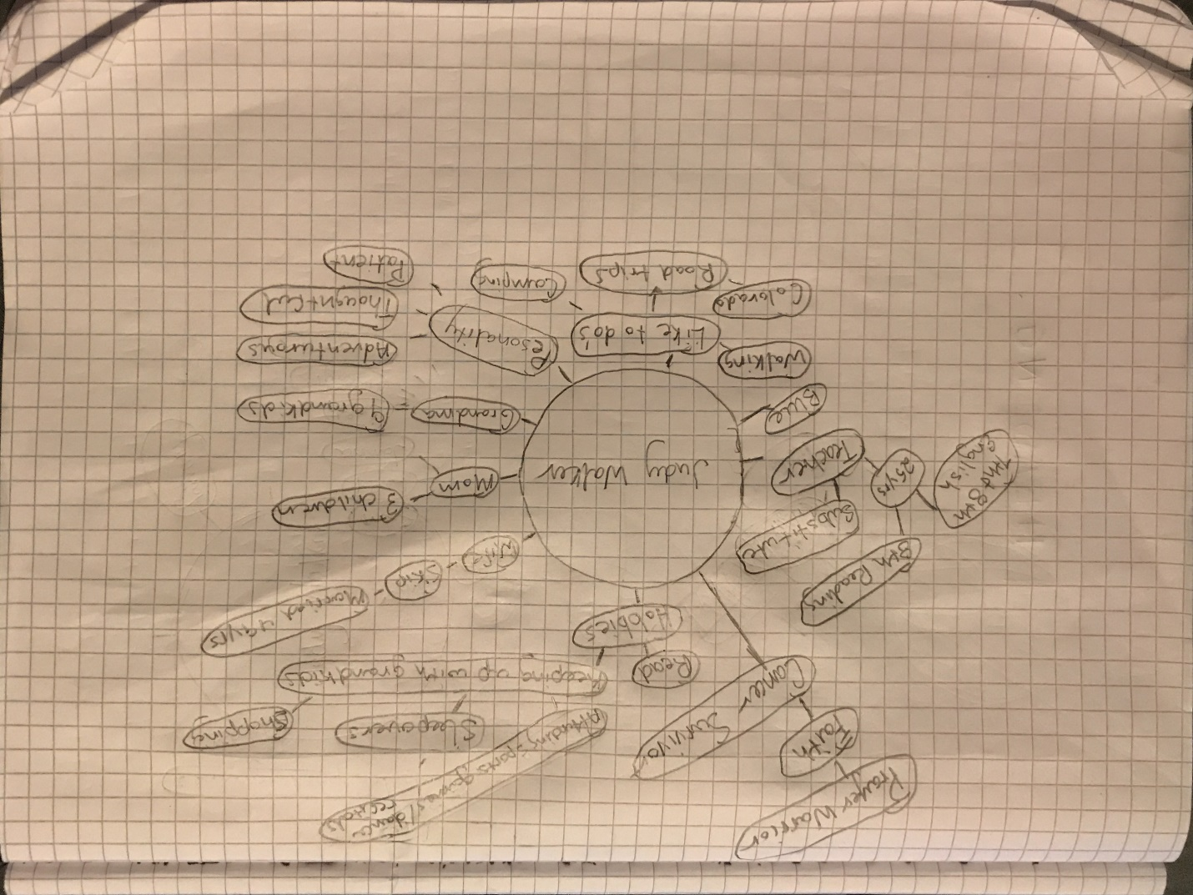**Ideas:**

For this project, I decided to create a bioSite for my grandmother Judy Walker. She has been a great role model for me and want to present why that is. My first idea was to generate a short interview with her to get more background information. I didn’t create a set of questions rather it was more of an open discussion. From this discussion I created a concept map that outlines important parts of her life. Keeping up with the grandkids, demonstrating her faith, and having a 25 year teaching career are of high importance on this map. Some other ideas that I was able to generate is creating a wordle and applying her favorite color blue to the site.

**Sketches:**

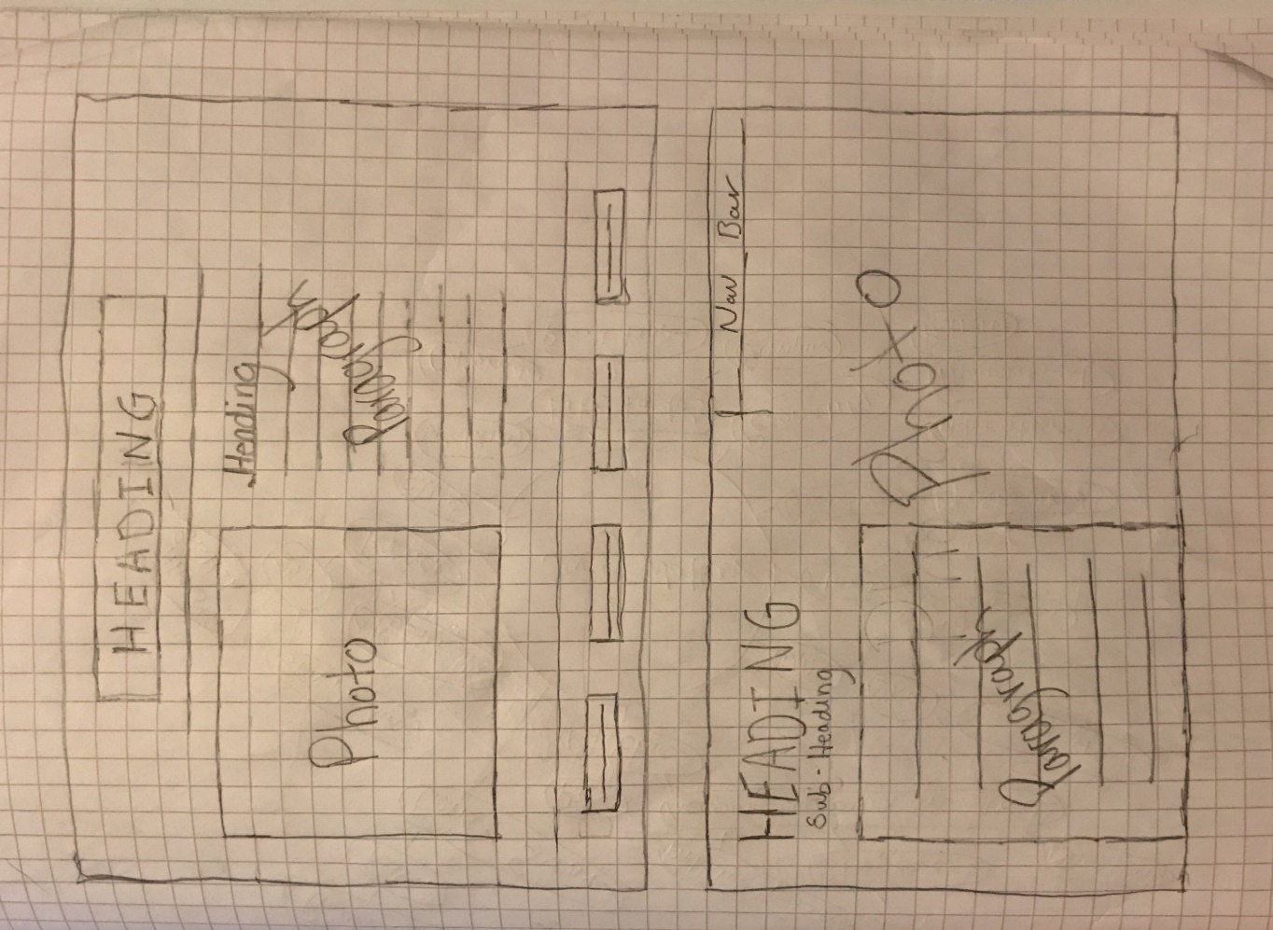

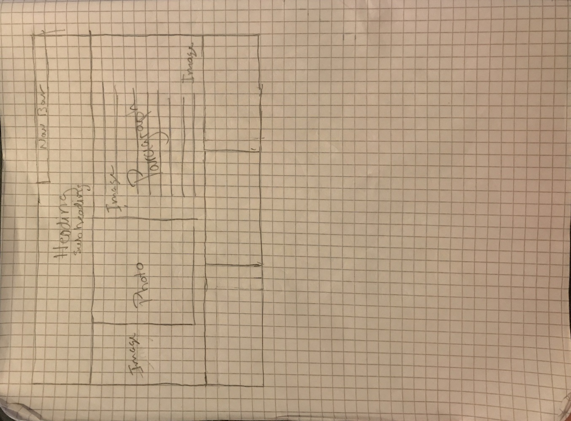

**Inspiration:**





